POLICY TITLE:
Procurement
- POLICY
Goods and services for Surrey Place (SP) must be properly acquired at the best value and in a timely and orderly manner.
All expenditure or commitments for expenditure for goods and services whether of an operating or capital nature are governed by and are to be made in accordance with this policy.
The policy and its associated procedures set out standardized rules for competitive and non-competitive procurement and contract awarding. The rules balance numerous objectives, including accountability, transparency, risk management, value for money and ultimately, effective and high-quality service delivery.
SP complies with the requirements of the Management Board of Cabinet’s Broader Public Sector Procurement Directive, 2011 and the Procurement Code of Ethics.
- PURPOSE
The purpose of this Statement of Policy and Procedure is to support the vision, mission and operational activities of SP with respect to the procurement of high quality, accessible goods and services:
    - At the best value through a process that is fair, open, consistent, transparent and accessible to qualified vendors;
    - From responsible environmentally conscious suppliers through a process that promotes equitable and ethical business practices and vendor relationships;
    - Through a competitive process in compliance with best procurement practices and legal requirements;
    - By utilizing purchasing agreements and co-operative purchasing contracts wherever feasible and appropriate;
    - In a collaborative, efficient and productive manner with SP user departments;
    - Through specified responsibilities of individuals and organizations throughout each stage of the procurement process

- SCOPE
This policy and its procedures apply to the procurement of all goods and services including consulting services and information technology required to meet SP needs except those related to accounting, public relations, media relations and the retention of outside legal counsel.
- RESPONSIBILITY
Senior Management (CEO, VPs, Directors, Managers) are responsible for:
    - Entering into procurement agreements and contracts on behalf of SP for the procurement of all goods and services required, according to approved policies and procedures;
    - Monitoring of and compliance with all procurement related internal controls;
    - SP wide communication and education of all procurement policies and procedures;
    - Monitoring and documentation of vendor performance, immediately addressing complaints about vendor performance and informing the Financial Analyst of vendor performance issues;
    - Periodic review and update of all procurement policies and procedures;
    - Establishing the appropriate internal controls related to all procurement processes and ensuring compliance with all controls;
    - Documenting and seeking approval for any exemption from the mandatory requirements of this policy.
The Procurement Officer (Senior Financial Analyst) is responsible for:
    - Development, management and co-ordination of the procurement process;
    - Monitoring all procurements to ensure compliance with the Broader Public Sector Procurement Directive, 2011;
    - Assisting with targeted procurement planning during the annual budget process;
    - Maintaining an up to date vendor of records (VOR) system;
    - Ensuring complete documentation for procurement exceptions, particularly when non-competitive procurement approach is used.
    - Ensuring board approval is obtained as per AAS.
    - Procurement records retention.
The Financial Analyst is responsible for:
    - Procuring goods and services required by SP, with due consideration for quality, availability, price, service and efficiency;
    - Assisting SP programs or departments in establishing requirements of goods and services as well as the development of standards and specifications;
    - Ensuring integrity of the procurement process and documentation;
    - Providing a responsive, cost effective, centralized service to SP staff

- DEFINITIONS
Consultant – a person or entity that under an agreement, other than an employment agreement, provides expert or strategic advice and related services for consideration and decision making.
Consulting services – the provision of expertise or strategic advice and related services for consideration and decision-making
Goods and services – any goods, construction and services, including but not limited to information technology and consulting services.
Lifecycle cost – the sum of all recurring and one-time costs over the full life span or a specified period of a good, service, structure or system. It includes purchase prices, installation costs, maintenance and upgrade costs.
Request for Proposal Process – a formal process involving a documented request of suppliers to submit written solutions and quotes for the delivery of complex products or services or to provide alternative options or solutions. It utilizes a predefined evaluation criteria and evaluation team to select a winning vendor in which price may not be the primary factor.

- REFERENCES and RELATED STATEMENTS
of POLICY and PROCEDURE
Broader Public Sector Procurement Directive, 2011
Broader Public Sector Procurement Guidebook 2011
- PROCEDURES
Mandatory Broader Public Sector Procurement Directive Requirements
The SP Finance Department ensures that SP complies with the mandatory requirements set forth by the Broader Public Sector Procurement Directive, 2011 in its procurement activities as summarized below:
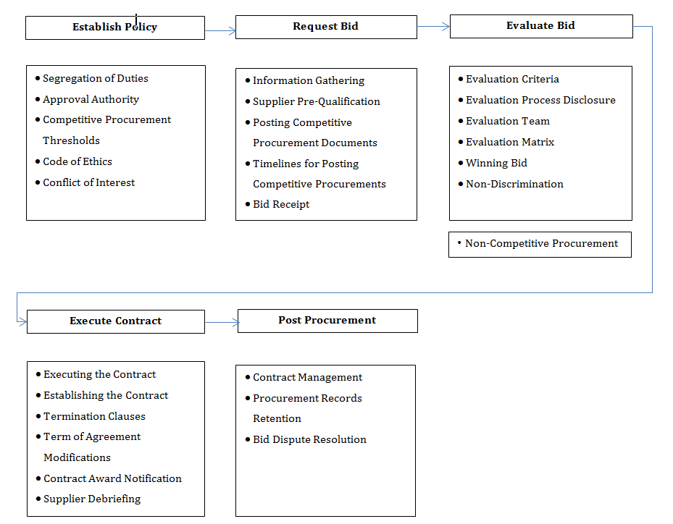
Procurement Principles
  - All SP staff are required to acquire goods and services in the most economical and efficient manner, through a process that adheres to the principles of:

    - Accountability – SP must be accountable for the results of its procurement decisions and the appropriateness of its procurement processes.
    - Transparency – SP must be transparent to all stakeholders. Wherever possible, stakeholders must have equal access to information on procurement opportunities, processes and results.
    - Value for Money – SP must maximize the value it receives from the use of public funds. A value-for-money approach aims to deliver goods and services at the optimum total lifecycle cost.
    - Quality Service Delivery – Front-line services must receive the right product, at the right time, in the right place.
    - Process Standardization – Standardized processes remove inefficiencies and create a level playing field.

Procurement Code of Ethics
All SP staff are required to adhere to the Procurement Code of Ethics that defines acceptable behaviours and standards that must be common for everyone involved with procurement activities throughout every stage of the procurement process such as planning, purchasing, contracting and payment as follows:

    - Personal Integrity and Professionalism – All individuals involved with procurement activities must act, and be seen to act, with integrity and professionalism. Honesty, care and due diligence must be integral to all procurement within and between SP, suppliers and other stakeholders. Respect must be demonstrated for each other and for the environment. Confidential information must be safeguarded. All participants must not engage in any activity that may create, or appear to create, a conflict of interest, such as accepting gifts or favors, providing preferential treatment or publicly endorsing suppliers or products
    - Accountability and Transparency – Procurement activities must be open and accountable. In particular, contracting and purchasing activities must be fair, transparent and conducted with a view to obtaining the best value for public money. All participants must ensure that public sector resources are used in a responsible, efficient and effective manner.
    - Compliance and Continuous Improvement – All individuals involved in procurement activities must comply with this code of ethics and the laws of Canada and Ontario. All individuals should continuously work to improve procurement policies and procedures, to improve their procurement knowledge and skill levels and share leading practices.
    - Delegation of authority - In case of temporary absence approver should delegate approval authority to equivalent or higher rank individual to authorize procurements, if delegate is not assigned due to any reason approval can also be obtained jointly from two members of executive team. Delegator is not allowed to further delegate approval authority and should remain ultimately responsible.

Conflict of Interest
A conflict of interest occurs when an employee’s professional actions or decisions are, or seem to be, compromised by consideration of personal gain.
To avoid actual and perceived conflicts of interest in purchasing and procurement, SP staff must adhere to the following guidelines regarding purchasing and procurement:
    - Wherever practical, purchasing decisions shall be made based on competitive bidding by using the pre-established bidding process;
    - Employees will not attempt to influence, directly or indirectly, the relationship between SP and a supplier for personal gain;
    - Employees will not disclose confidential purchasing information to any supplier during a tendering process;
    - Employees will not only avoid actual but also perceived conflicts of interest in the process of making decisions on purchasing and procurement;
    - Employees will not seek or accept gratuities, or anything of value given which could influence the decision of purchase;
    - SP will purchase goods and services from an employee or any employee’s immediate family, domestic partner or a business in which an employee or his/ her immediate family or his/ her domestic partner holds a substantial financial interest, if and only if the decision maker to purchase such goods and services is an employee with no conflict of interest in the purchase and not subordinate to the employee with the conflict of interest.
    - Authorizer is not allowed to approve its own expenses, to ensure transparency it is necessary that expenses must be authorize from higher rank officer.

Segregation of Duties
Segregation of duties, across functions and individuals, is an essential control that ensures integrity of the procurement process by reducing exposure to inappropriate, unauthorized or unlawful expenditures. It prevents any person from controlling the entire procurement process by segregating approvals and roles for budgeting, requisitioning, commitments, receipt and payment. All SP staff must be vigilant in ensuring responsibilities for each of these are with different personnel, programs or departments

Initiating Procurements
Each program or department is responsible for identifying its needs, defining its requirements and ensuring the availability of funds using the electronic Purchase Requisition or Procurement Requisition Form.

New Vendor: Vendor evaluation form and new vendor setup form are required to set up new vendors. Finance Team conducts screening and works with procurer and new vendor to complete the forms. New vendor is approved by Director, Finance.
The Purchase Requisition or Procurement Requisition Form must be fully completed with cost centre and account number and reviewed and approved by the appropriate level of authority as per the Approval Authorization Schedule.
The approved Procurement Requisition Form must be submitted to the Procurement Officer for procurement records retention and coordination of appropriate quotes per the Approval Authorization Schedule
Procurements related to maintenance material or work order must be submitted via help desk ticket to Facility Department. Facility Department will submit electronic purchase requisition or procurement requisition to Finance Department with assigned ticket number for further processing.
Professional Service agreement (PSA): PSA is required for Procurements of consulting and non-consulting services that having value of $ 3,000 and above. Once the approved procurement requisition is received by Procurement officer it will send copy of approved procurement requisition to People services specialist of people services department to create PSA.

Approval of Procurements
The SP Board of Directors, by board motion, delegates financial authority and approvals to job roles and ensures that authority and approval levels correspond to job roles commensurate with the responsibility level for the position.
All goods and services must be purchased within each program or department’s approved budget and are subject to authorization and approval as per the Approval Authorization Schedule as follows:
Goods & Non-Consulting Services
Amount (excluding tax) | Approval Authority | Method of Procedure
$0 to $2,999 | Manager or Supervisor | Electronic Purchase Requisition (optional) / Corporate Visa Card with 1 written quote
$3,000 to $9,999 | Supervisor | Procurement Requisition with 1 written quote
$10,000 to $49,999 | Director | Procurement Requisition with 3 written quotes
$50,000 to $199,999 | CEO or Vice President | Procurement Requisition for$50,000 to $99,999 with 3 written quotes  Procurement Requisition for $100,000 to 199,999 and publicly posted RFP
$200,000 to $499,999 | CEO and Vice President | Procurement Requisition and publicly posted RFP
$500,000 or more | CEO and 1 Board member with signing authority | Procurement Requisition and publicly posted RFP

Consulting Services (provision of expert or strategic advice and related services for consideration and decision-making)
Amount (excluding tax) | Approval Authority | Method of Procurement
$0 to $9,999 | Manager and Supervisor | Procurement requisition/ 3 written response
$10,000 to $49,999 | Director | Procurement requisition/ 3 written response
$50,000 to $199,999 | CEO or Vice President | Procurement requisition for $50,000 to $99,999 with 3 written responses  Publicly posted RFP for $100,000 to 199,999
$200,000 to $499,999 | CEO and Vice President | Publicly posted RFP
$500,000 or more | CEO and 1 Board Member with signing authority | Procurement Requisition and publicly posted RFP

Exception – Based Only, Non-Competitive Procurement
Amount (excluding tax) | Approval Authority | Method of Procurement
$0 to $499,999 | CEO | Single/ Sole source documentation
$500,000 or more | CEO and 1 Board Member with signing authority | Single/ Sole source documentation

Procurer must not reduce the overall value of procurement (e.g., dividing a single procurement into multiple procurements) to circumvent the approval requirement as per Approval Authorization Schedule. In case of contract extension procurer should add initial procurement value to obtain approval as per Approval Authorization Schedule.

Receipt of Quotes and Confirming Procurements
In accordance with the Approval Authorization Schedule above, the procurer is required to work with the Procurement Officer and Financial Analyst to secure and retain:
    - The appropriate number of quotes
    - Select the appropriate vendor based primarily on the lowest cost or best value for money
    - Document the rationale for selection of the winning vendor
The Financial Analyst will work with the procurer utilizing the approved Purchase Requisition or Procurement Requisition to create a Purchase Order.

The procurer will work with the Procurement Officer to create a formal Request for Proposal for all procurements of $100,000 or more. The Request for Proposal Process will comply with the requirements of the Broader Public Sector Procurement Directive, 2011.

Exemptions from Competitive Procurement Procedures
A procurer requesting an exemption from competitive procurement procedures is required to work with the Procurement Officer to note the reason for the requested exemption on the Procurement Requisition and seek approval of the Chief Executive Officer.
The Chief Executive Officer may approve an exemption under one or more of the following situations:
    - Real estate acquisitions and leasing agreements;
    - Services provided by Licensed Professionals such as Medical Doctors, Psychologists, Engineers, Architects, Certified Public Accountants and Lawyers;
    - Only one consultant has the unique qualifications or experience required to perform a specific task;
    - Unforeseen situations of an urgent or emergency nature;
    - Confidential tasks for which it is inappropriate to solicit proposals from a number of sources;
    - A task is a follow-up from a previous task performed; or
    - The vendor is transferred from another agency to continue an unfinished project
    - Absence of receipt of bids in response to RFP conducted in compliance with BPSAA.
Procurer should inform procurement officer for those contracts which were awarded based on non-competitive procurement criteria from the last two years. It is necessary for procurer to work with procurement officer to test the market for vendor availability by using methods such as (RFP,RFQ).
Should there be a question about whether the proposed vendor could be viewed as an employee versus a third-party vendor, the procurer is required to work with the Procurement Officer to complete the Purchase of Service Agreement form for review and approval by People Services.
Once all approvals have been completed, the procurer is required to work with the Procurement Officer to create a Purchase of Service Agreement Contract with the vendor and People Services.

Receipt of Goods and Services and Processing of Payments to Vendors
Procurer should ensure that all the goods are delivered to official agency location except for those which approves as “Client needs funds”.
Upon receipt of goods or completion of services, the procurer and Financial Analyst is required to forward all appropriately approved supporting documents to the Accounting Clerk for processing, inclusive of Purchase or Procurement Requisition, Purchase Order, Receiving Documents and Vendor Invoice along with appropriate cost centre and department coding on the invoice.
The Accounting Clerk will review and verify all documents and approvals or seek appropriate clarifications or further documentation as needed to ensure compliance with this policy before processing payment.
Submission of approved invoices by email, submitted to Finance should include the following language:

“I approve the following invoice(s) for payment:
X company, invoice no., in the amount of $$$.$$.
Charge to Deptxxx, Account xxxx.”
- Vendor Debriefing

As per BPSPD vendors are entitled for debriefing for procurements valued at $100,000 or more. Surrey Place allow unsuccessful vendors 60 calendar days following the date of the contract award notification to request a debriefing.

- ATTACHMENTS
Procurement Map
Electronic Purchase Requisition Form (Via Teams)
Procurement Requisition Form
Vendor Evaluation Form
New vendor setup form

- REVISION HISTORY

Date Reviewed | Reviewer  (Director or designate) | Comments
02-Oct-23 | Director, Finance | 7.14 Approval Authorization Schedule updated
03-Jun-21 | Director, Finance | 7.08 New vendor screening process; 8. Threshold for vendor debriefing; Update to 7.12, threshold for PSA
27-Jun-19 | Manager, Finance | Update to 7.11 Approval Authorization Schedule
04-Oct-19 | Coordinator, Special Projects | Updated Policy Template

