STATEMENT OF POLICY AND PROCEDURE

Department: | Finance & Administration |  | Policy Number: | FIN-009
Approved by: | Executive Team |  | Accountability: | VP, Finance & Corporate Services
Operational Lead: | Director, Quality & Performance |  | Policy Origin Date: | March 19, 2009
Revision Date: | May, 2023 |  | Review Date: | May, 2025

POLICY TITLE:

Travel, Meal, and Hospitality Expenses

POLICY
  - Surrey Place will reimburse reasonable and necessary travel and meal expenses incurred while conducting Surrey Place related business. This policy and procedures are in accordance with the Management Board of Cabinet Broader Public Sector Expenses Directive Effective April 01, 2011.

PURPOSE
  - The purpose of this policy is to support the Vision, Mission and operational activities of Surrey Place, and to establish the principles, mandatory requirements and guidelines for reimbursing individuals for travel, meals and other reasonable expenses incurred on behalf of Surrey Place.

SCOPE
  - This Policy applies to all Surrey Place’s employees, students, volunteers, third parties engaged by Surrey Place to provide consulting or other services, and Board Members, who incur business related expenses on behalf of Surrey Place.

PRINCIPLES
  - The overall objective of this policy is to ensure that Surrey Place complies with the four principles set forth in Broader Public Sector Expenses Directive Effective April 1, 2011 as follows:
    - Accountability: Surrey Place is accountable for public funds used to reimburse travel, meal and hospitality expenses.
    - Transparency: Surrey Place is transparent to all stakeholders. The procedures for incurring and reimbursing travel, meal and hospitality expenses are clear, easily understood, and available to the public.
    - Value for Money: Plans for travel, meals, accommodation and hospitality are necessary and economical with due regard for health and safety.
    - Fairness: Surrey Place reimburses legitimate authorized expenses incurred during the course of business of Surrey Place.

DEFINITIONS
  - None noted.

REFERENCES and RELATED STATEMENTS of POLICY and PROCEDURE
  - Broader Public Sector Expenses Directive 2011
  - Broader Public Sector Expense Rules 2014

PROCEDURES
  - The use of privately owned motor vehicles on the Employer’s business is not a condition of employment.
  - Travelers must use the most practical and economical way to travel.
  - Travelers shall not transport clients in their personal motor vehicle.
  - Travelers are not considered on business when they travel to and from home to the office or first visit at the start and close of their business day.
  - Travelers using their motor vehicle for business purposes are advised to inform their auto insurance carrier and carry appropriate insurance.
  - Parking expenses for business purposes will be reimbursed based on the scan copy of original parking receipt, for recordkeeping purpose employee must keep original receipt for 12 months.
  - There is no reimbursement for traffic or parking violations.
  - Parking at Surrey Place sites: please refer to the Parking Policy.
  - All staff are designated to a Surrey Place office, including home-based staff. Parking at your designated Surrey Place location is not reimbursable. If staff travel from their designated office to another location during the course of the business day, parking may be reimbursed.
  - Good record-keeping practices should be maintained for verification and audit purposes.

ACCOUNTABILITY FRAMEWORK
  - Approval Authority Schedule:
All travel expenses must be approved appropriately prior to the travel, in accordance with the approval authority listed below:

Level of Approval Required for Travel Plans
Role | Travel in Ontario | Travel in Canada and  continental USA | International Travel
CEO | Board President | Board President | Board President
Employee, Student,  Volunteer | Manager/Supervisor | Program Vice  President | CEO
Consultant | Contract Manager | Program Vice  President | CEO

  - Claimants are expected to:
    - Obtain all appropriate approvals before incurring expenses;
    - Submit original, itemized receipts with all claims;
    - Submit claims within thirty (30) days after the completion of travel, except for the month of March;
    - Submit all approved travel expense claims incurred during the month of March within the first five days in April;
    - If the information above is not available or is not possible, submit a written explanation with the claim to provide the approver with adequate information for decision-making;
    - Repay any overpayments – it is considered a debt owing to Surrey Place;
    - If leaving employment with Surrey Place, submit any claims for expenses before leaving Surrey Place.

  - Approvers are expected to:
    - Provide approval only for expenses that were necessarily incurred in the performance of Surrey Place business;
    - Provide approval only for claims that include all appropriate documentation;
    - Not approve their own expenses;
    - Claimed expenses for a group can only be by the most senior person present. Expenses cannot be claimed by an individual that are incurred by his/her approver.

EXPENSES INCURRED FOR CONSULTANTS AND OTHER CONTRACTORS
  - Surrey Place will not pay or reimburse a consultant for any hospitality, incidental or food expenses, including but not limited to expenses in respect of meals, snack, beverages, gratuities, laundry or dry cleaning, valet services, dependent care, home management and personal telephone calls.
  - Reimbursement for allowable expenses can be claimed and reimbursed only when the contract specifically provides for it.

MILEAGE
  - If a traveler is required to use his/her own motor vehicle on the Surrey Place’s business, the employee shall be reimbursed at the rate of fifty (50) cents per kilometer. The mileage rate includes reimbursement for insurance, gas, and depreciation of vehicle.
  - Mileage reimbursements should be calculated from the assigned Surrey Place location.
  - For Home Based travelers travel to or from their assigned Surrey Place location is not reimbursable when this is the first or the last visit of the day, unless if the distance between the employee’s home and the first visit (or between the last visit and the employee’s home) is greater than the distance normally travelled between the employee’s home and the employee’s assigned Surrey Place location, the difference can be claimed.

  - For all other travelers, travel to their assigned Surrey Place location is not reimbursable. For business meetings during the course of the business day reimbursement is based on the distance from their assigned Surrey Place office to the meeting site and return mileage to the assigned Surrey Place office.

Travelers can use below mentioned illustration to calculate appropriate mileage for reimbursement.
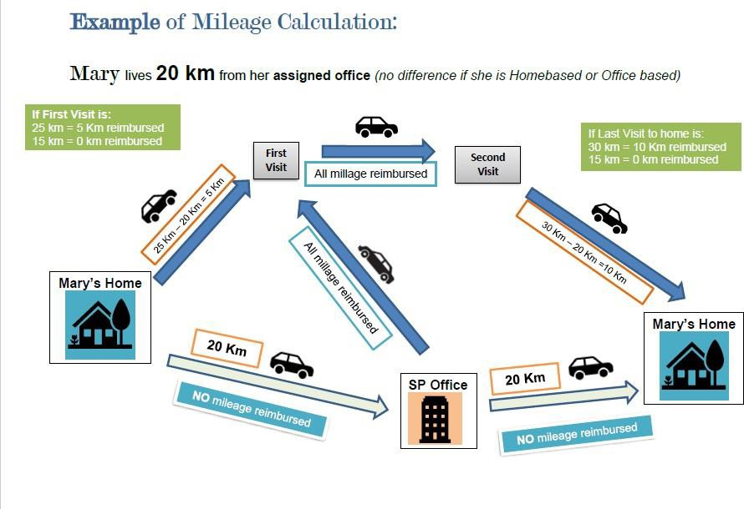

  - On a regular basis, the Finance Department will select random samples of mileage claims and verify the accuracy and reasonableness of distances claimed, by using an online trip calculator to calculate the trip distance. The onus is on travelers to accurately track their actual distance. In the event of an overpayment of a mileage claim, such overpayment will be recovered promptly from the traveler.

TRAVEL
  - For Public Transit, staff are permitted to claim reimbursement for the cost of TTC fare for Surrey Place business related travel by:
    - Providing the required reimbursement information on the TTC Travel Reimbursement Form
    - Coding the cost to their program or department and
    - Obtaining approval from their immediate supervisor.

  - Taxi Chits are available on a limited basis, and provided on approval by Finance Department The chit must be properly signed and with the amount and cost centre

clearly indicated. If travelers tender their own fares for taxi services, receipts and documentation of the business purpose for the travel are required for reimbursement.
  - Automobile Rental:

    - Travelers should make their own arrangements for automobile rentals with prior approval by using Purchase or procurement requisition or ask Accounting Clerk to make arrangement.
    - The original receipt from the rental agency should be attached to the Travel Expense Form for reimbursement.
    - Travelers should accept the rental car insurance for collision and loss, unless otherwise covered.
  - Air/Rail:
    - Travelers must use the most economical and direct route.
    - Travelers are expected to book economy class when making travel reservations.
    - Business class may only be permitted with approval by the CEO, taking into consideration such relevant factors as health and safety, or business circumstances.
    - Travelers are responsible to submit approved purchase or procurement requisition to make travel arrangements by Accounting Clerk.
11.06Accommod ations
a) Travelers are responsible to submit approved purchase and procurement requisition to make accommodation reservation by Accounting Clerk.

ALCOHOL
  - Alcohol cannot be claimed and will not be reimbursed as part of a travel or meal expense. There are no exceptions to this rule.

MEALS
  - When travelling outside the City of Toronto overnight, expenses for meals excluding alcoholic beverages will be reimbursed with supporting scan copy of original itemized receipts. for recordkeeping purpose employee must keep original receipt for 12 months. The reimbursement must not exceed the Max MealRates listed below, including taxes, and gratuities.
.

Max Meal Rates in Canada (including tax)
Meals | Effective June 1, 2016 Maximum Amount
Breakfast | $10.00
Lunch | $15.00
Dinner | $25.00

Max Meal for MMW Mobile Team (including tax)
Meal | Effective Feb 1, 2020 Maximum Amount
Whole day meal | $60.00

  - Except for MMW mobile team maximum rates apply to each meal and may not be accumulated for missed meals within one single day.
  - In rare circumstances where meal rate maximums cannot be adhered to (for example travel to remote sites in Northern Ontario), a request must be made in writing to the respective Vice-President for prior approval and the approved documentation submitted with the expense claim for approval by the VP, Finance and Corporate Services and processing in the Finance Department
  - The provision of food and beverage to facilitate Surrey Place’s business will be reimbursed with supporting scan copy of original itemized receipts, for recordkeeping purpose employee must keep original receipts for 12 months. The name of the associate and purpose of the meeting must be noted on the receipts. The amount must be appropriate and reasonable.

HOSPITALITY
  - Hospitality is the provision of food, beverages, accommodation, transportation and other amenities paid out of public funds to people who are not engaged to work for Surrey Place, any of designated BPS organizations covered by Broader Public Sector Expenses Directive, the Ontario government ministries, agencies and public entities covered by the OPS Travel, Meal and Hospitality Expenses Directive.
  - Activities involving only those people in the organizations listed above are not considered hospitality and cannot be reimbursed.

SOCIAL EVENTS, BUSINESS MEETINGS, AND CORPORATE EVENTS
  - Staff social events must be consistent with Human Resources Life Event Policy. 15.02Reimbursement of catering for business meetings with external guests and internal staff
occurred over the timing of breakfast, or lunch is permissible with the approval of the Vice President of the program.
  - Reasonable and appropriate catering expenses for internal staff may be reimbursed for a whole day meeting or a meeting is unavoidably held over a normal meal period, subject to approval by the respective vice president. Catering expenses must be supported by scan copy of original itemized receipts, list of attendees and business purposes for themeeting. For recordkeeping purpose employee must keep original receipts for 12 months.

  - Corporate events such as staff recognition, awards ceremonies, project celebration, engagement events and others may be offered for the benefit of Surrey Place’s staff. The cost of events should be appropriate to the circumstance and will be charged to non-government funds. If alcohol is provided at a hospitality event, it must be pre- approved by the CEO, designate or Board President.

REIMBURSEMENT PROCEDURES
  - The following primary procedures will be used to guide the reimbursement of travel expenses.

    - The Travel Expense Form attached with receipts shall be submitted to the Finance Department for reimbursement. The form must be approved by the employee’s manager. Employees should keep original copies of their receipts and the Travel Expense Form.
    - Reimbursement of expenses for the Chief Executive Officer shall be approved by the Board President, or his/her authorized Board Member.
    - Except for the month of March, all expense claims should be presented for payment within thirty (30) days after the completion of travel.
    - All travel expense claims made during a given fiscal year must be submitted within the first five (5) days in April of the following fiscal year to ensure they are charged to the same fiscal year.
    - Accounts Payable staff will process duly prepared and appropriately approved claims in a timely manner.

ATTACHMENTS
  - Travel Expenses Reimbursement Form: Travel Reimbursement Claim form

- REVISION HISTORY

Date Reviewed | Reviewer  (Director or designate) | Comments
17-May-23 | Director, Finance | Update to 7.09 Procedure
22-Mar-23 | Director, Finance | Update to 10.01 Mileage
1-Jun-19 | VP, Finance & Corporate Services | Update to 8.01 Approval Authority Schedule
4-Oct-19 | Coordinator, Special Projects | Updated Policy Template
14-May-20 | Manager, Finance | Updates to travel, mileage, and meals section

